CS 224 – LAB 4B

Write-Back (WB) Stage

Student Details
- Name: TODO: Fill
- Roll No: TODO: Fill
- Group Number: TODO: Fill
- Date: TODO: Fill

Please note:
Students must be able to explain the code they submit (whether provided or written by them).
If a student cannot explain a component, marks for that component will not be awarded even if it works.
⚠ No marks will be awarded if the block diagram is not shown.

1. Block Diagram (2 marks)

Requirement
Draw the Write-Back (WB) stage system of a RISC-V processor as a standalone, clocked datapath unit.
📌 Use:
- Combinational blocks: muxes, comparators, decoders
- Sequential blocks: registers, synchronous memories
☑ Program Counter (PC) register
☑ Instruction Memory interface (address + ready)
☑ Load data formatting logic (sign / zero extension)
☑ Store data and byte-enable generator
☑ Branch stall generation logic
☑ Control signal gating during stall
☑ Observable outputs (PC, write-back data, byte enables)
TODO: Paste the image of a hand drawn block diagram here

2. Timing Diagram (1.5 marks)

Minimal signals to be shown
- clk
- stall_read_i
- wb_branch_i
- wb_stall_first_o, wb_stall_second_o
- wb_write_byte_o
- wb_read_data_o
- inst_fetch_pc_o

Conditions to Demonstrate
☑ Load instruction with correct sign / zero extension
☑ Store instruction with correct byte enables
☑ Two-cycle branch stall behavior
☑ PC held constant during stall cycles
📌 Minimum 10 clock cycles required
TODO: Paste the image of a hand drawn timing diagram here

3. Design (2 marks)

Verilog Files Used
- wb.v
- opcode.vh

Design Description
The WB stage:
- Selects the final write-back value (ALU or memory)
- Formats load data (LB, LH, LBU, LHU, LW)
- Generates store write data and byte-enable strobes (SB, SH, SW)
- Produces a two-cycle stall for branch instructions
- Forwards the program counter for instruction fetch
- Suppresses write-back and store operations during stall
TODO: Add screenshot of your wb.v code (highlighting TODO sections)

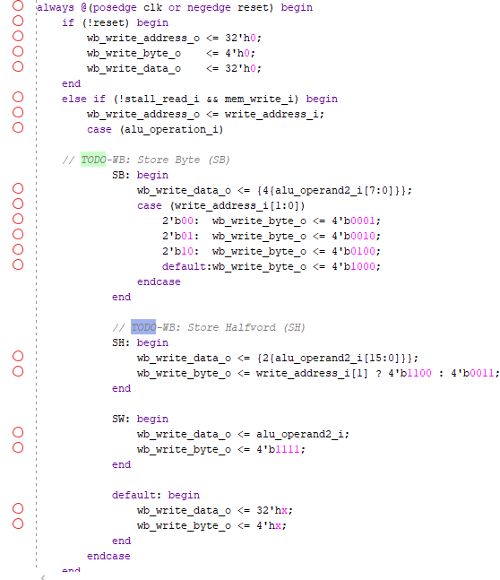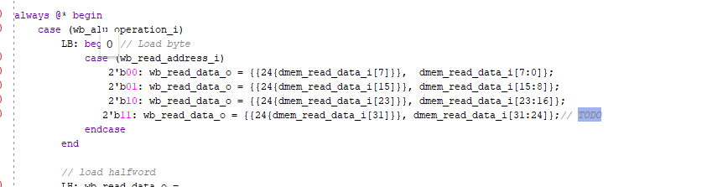

4. Validation Using Simulation (1 marks)
Testbench
- tb_wb.v

Verification Method
Functional simulation using waveform inspection and logged outputs.

Outputs Logged To
- wb_out.txt

Cycle-by-Cycle Validation of
☑ Correct load data formatting
☑ Correct byte-enable generation
☑ Correct PC update behavior
☑ Correct two-cycle branch stall
☑ No unintended writes during stall

Result
☑ Simulation completed successfully
☑ Output behavior matches expectations
TODO: Paste waveform screenshot here

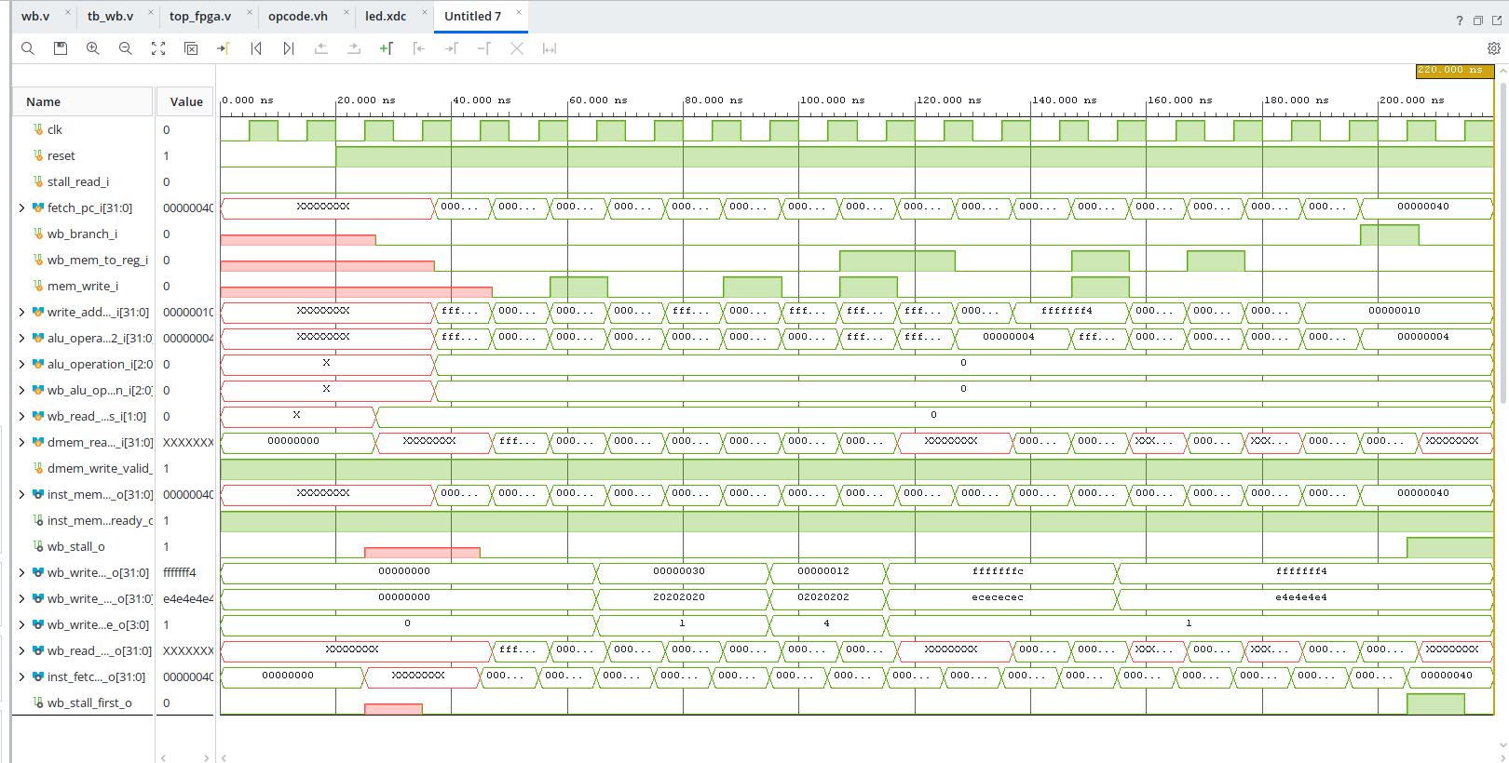

5. FPGA Demo (3 marks)

Hardware Used
- Nexys A7 FPGA Board

Files Used
- top_module.v
- wb.v
- constraints.xdc / led.xdc

FPGA Mapping
- Clock → On-board 100 MHz clock (via divider)
- Write-back data or PC → LEDs
- Optional slow clock for visibility

Observation
☑ Bitstream generated
☑ FPGA programmed
☑ Load/store behavior visible on LEDs
☑ Branch stall cycles clearly observable
☑ PC remains stable during stall
TODO: Add screenshot of the code you have added (in constraints.xdc)
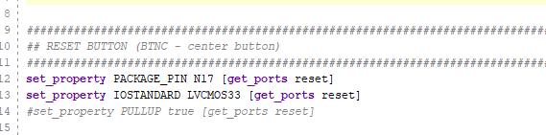
TODO: Add FPGA Screenshot showing the LED output

6. Bug Identification (0.5 mark)

Bug Identified / Explained / Fixed

TODO: Briefly describe the bug identified during evaluation
☑ Bug correctly identified
☑ Explanation and fix provided
1. Added reset functionality and corrected clock divider functionality.

